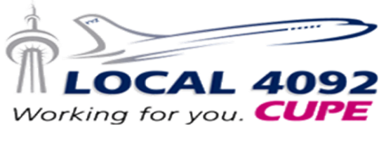
Health & Safety Report – September 2020
May 2020 – August 2020
Number of Reported Injuries/Illnesses
Lost Time | 23 | Health Care | 3

Top Injury/Illness Trends
Biological Hazards/Illness – COVID-19 | 7
Slip/Trips/Falls/Contact with Hotel Use Items | 4
Biological Hazards/Illness | 3

The COVID-19 pandemic continues to affect our lives and has taken up the majority of our focus since the spring. The Health & Safety Committee was amazed and grateful for the strong response from crew about their health and safety concerns. In March, cabin crew submitted a record number of Health and Safety Complaints and exercised their right to refuse dangerous work. Through these actions, the Health & Safety Committee was able to secure significant changes in service, procedures, and personal protective equipment. It’s all a part of the three fundamental rights of every Canadian worker: 1) the right to know; 2) the right to participate; and 3) the right to refuse.

We encourage crew to keep submitting Health and Safety Complaints whenever they feel something at the workplace may negatively affect their health and safety. It’s easy to do! You’ll find the Health and Safety Complaint at ACaeronet / Safety / Submit a Safety Report/SIMS. Sign-in using your ACaeronet credentials. We recommend typing the complaint in a separate document first so that you can easily make changes and save it. Before submitting the eReport, be sure to “Set Department” to “In-Flight Service.” If you encounter any technical issues, take a screenshot and e-mail it to us for follow-up (PC: CTRL + PRT SC, then CTRL + V in the e-mail / MAC: SHIFT + COMMAND + 3, then COMMAND + V in the e-mail). The paper-based ACF32 Employee Safety and Health Form is still available at the Crew Centre.

As we adjust to this brand new world, we must stay informed and up-to-date on the latest best practices and procedures. Once again, if you feel these changes run against your health and safety: report it!

Mandatory Temperature Screening – Canadian Airports:
As of July 30, crew must have their temperature taken when going through security in YVR, YYC, YYZ, and YUL, with other airports to join in later. Those infected with COVID-19 do not always have a fever. However, this is an easy way to screen people for the virus or any other illness.

COVID-19 Releases:
If there was a positive case of COVID-19 on a flight you operated, you will be contacted by the COVID-19 contact tracing team. Crew COVID-19 self-isolation release procedures changed on September 1. When contacted, you have two options: 1) self-isolate for the remaining 14-days following the exposure, or 2) test negative for COVID-19 and return to work upon confirmation of test results. You will be pay protected for any missed flights regardless of what option you choose. If you are contacted while on layover, you must operate your remaining flights until you return to home base.

Denied Services:
The Union and the Health & Safety Committee are aware that crew are being denied basic services because of the nature of our work. We shared your concerns with the Public Health Agency of Canada and we’re hopeful that change will come from this. We discussed the ArriveCan app and ensuring Canadian Border Services Agency officers enter the right exemption code for crew, and the possibility of advising professional associations of our exemption (e.g. Canadian Dental Association and Canadian Medical Association).

Disruptive / Unruly Passengers and Face Coverings:
The Company must report each occurrence of non-compliance of face covering rules onboard (Transport Canada’s Order Respecting Certain Requirements for Civil Aviation Due to COVID-19, No. 5). You’ve been very vocal about the challenges of enforcing the face covering rules onboard and we understand your frustrations. By submitting a Disruptive Passenger Security eReport (ACaeronet / Safety / Submit a Safety Report/SIMS), you’re ensuring that the Company logs and reports all incidents to Transport Canada. The paper-based ACF34D Disruptive/Unruly Passenger Report is available in the Crew Centre.

Designated Crew Lavatories:
The forward lavatory was designated for crew-use-only until recently. The Union and Health & Safety Committee believe that the designated lavatories served to improve crew health and safety onboard through the precautionary principle (we shouldn’t wait until certainty is confirmed absolutely before making changes to protect our health) and the hierarchy of controls (hazards should be mitigated through elimination, substitution, engineered changes, administrative procedures, then personal protective equipment, in that order). The designated lavatory was an example of the precautionary principle and administrative procedure in action.

Face Coverings:
Cabin crew must wear a mask (surgical or N95 respirator) and gloves at all times (FAM Insert 306 – Safety During COVID-19 - Update). This includes the galleys, Overhead Flight Attendant Rest Areas (OFAR), and the flight deck. Cloth face coverings or face shields without a mask underneath do not provide appropriate protection.

In Solidarity,

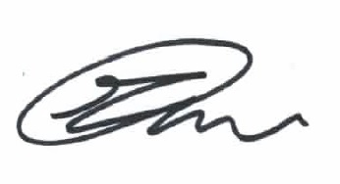 |  | 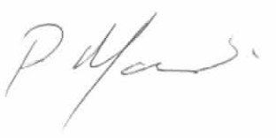
Meaghan Mroczek-Porato |  | Pascale Marchand
Health & Safety Committee Chair |  | Health & Safety Committee Representative
E: meaghan@local4092.ca |  | E: pascale@local4092.ca
Health & Safety Committee
T: 905-676-4352
E: sante.health@local4092.ca

